Sam Lummus

GIMM 200

Karen Doty

April 23, 2023

UX Design Results

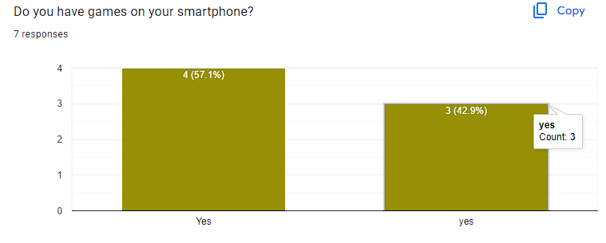

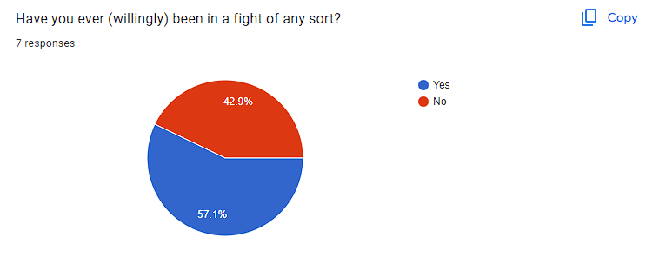

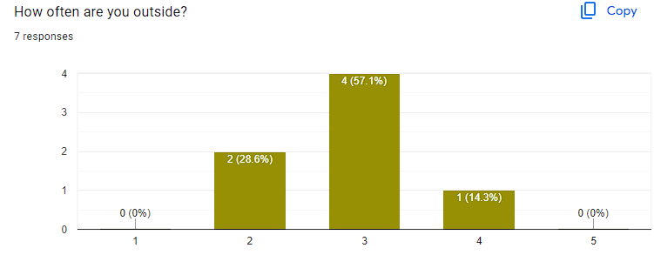

These were the results of my pre-interview questions. The last question was on a scale of 1 being a lot, and 5 being not at all. Based on the results, I would say that most, if not all of my participants fit the criteria for the app's audience.

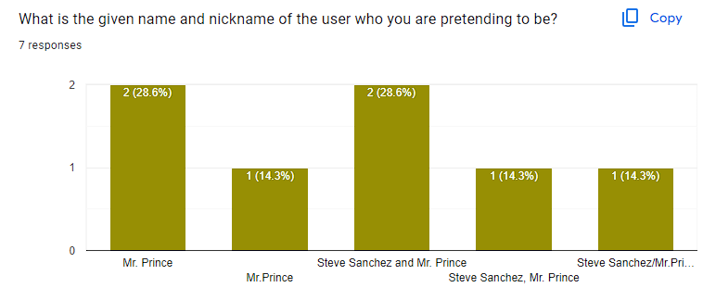

This was my first question for my scavenger hunt. The information as not hidden very deep, and over half of my participants got the answer right. For those who did not, I would chalk it up to user error for not reading my question thoroughly. The profile had the given name and nickname on it, right next to each other.

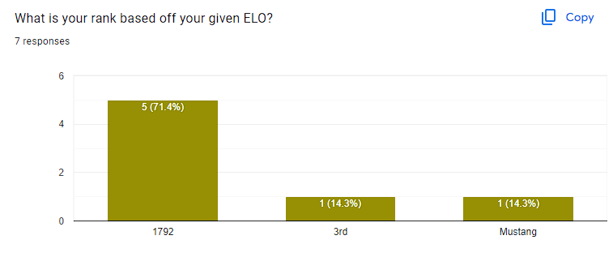

This question looks like it was answered correctly, but my desired answer to the question was “Mustang”. I wanted people to correlate the rank of the user they were impersonating to the chart I had placed next to it on the ranking page. I could have phrased the question better, but at least the participants were able to find the first necessary piece of information.

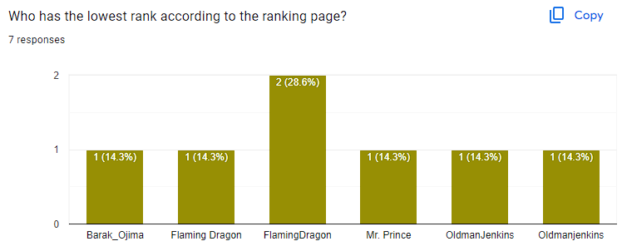

This question had the highest variation of answers. I needed participants to navigate a drop down menu in order to sort the rankings from low to high, and I wanted to know who held the lowest ranking. Their ELO number should have given it away. Those who said FlamingDragon, most likely did not navigate away from the global ranking page (default page when you launch it). The ordering of the highest rankings (or in this case lowest) might have tripped up the person who answered Barak_Ojima, as they successfully navigated to the lowest ranking page, but chose the user in 5th place, not 1st. The question definitely should have been simplified or phrased differently.

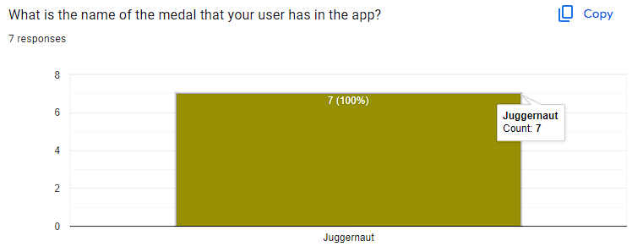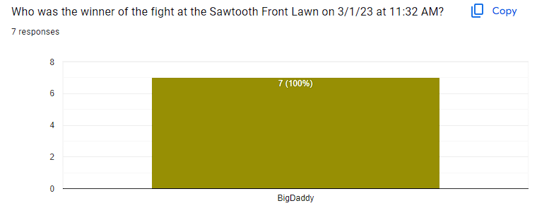

These last questions had unanimous answers across all participants. The medal was a simple toggle click on the ranking page. Finding the winner was hidden behind a page transition. Nothing confusing about the phrasing or where to find the answer.

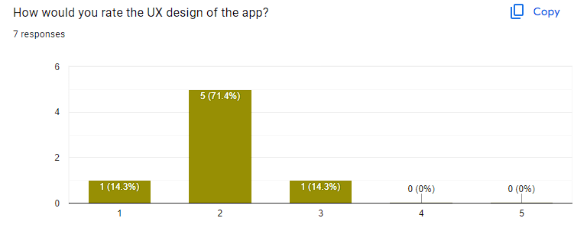

Overall, my participants rated my design of the app above average, with 1 being the highest and 5 being the lowest.

Many said that the items on the checklist were not hard to find.

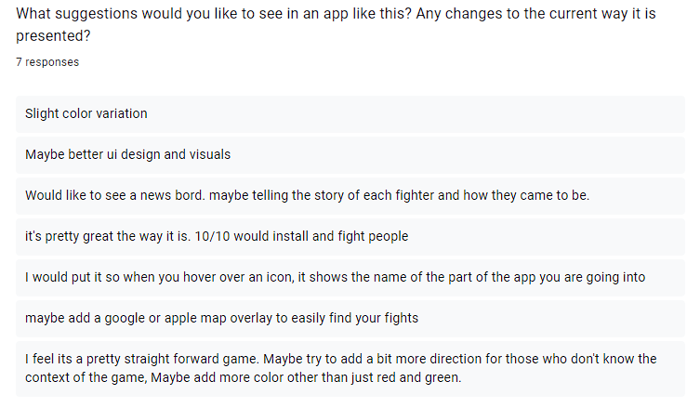

The hover over an icon to see the destination of the button idea is the number one thing I would incorporate into my app if I could go back and do it again. A news board for the history of users activity would be interesting, and a great thing to include on their profile pages.

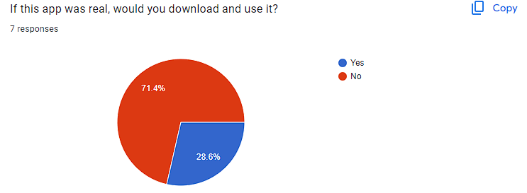

Due to the nature of the app, most users would not download and use the app. I kind of expected this, but I wanted to simulate this app as if it were a real thing.